**Challenge g**

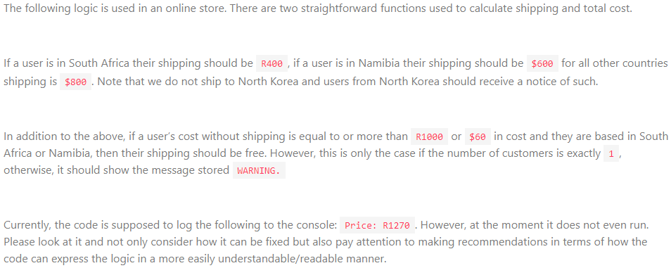

FREE_WARNING = 'Free shipping only applies to single customer orders'

BANNED_WARNIN = 'Unfortunately we do not ship to your country of residence'

NONE_SELECTED = '0'

if (location = RSA) { shipping === 400 && currency === 'R' }

if location = NAM

shipping = 600

else shipping = 800

shoes = 300 * 1

toys - 100 * 5

shirts = 150 * 'NONE_SELECTED'

batteries 35 * 2

pens = 5 * 'NONE_SELECTED'

shipping = null

currency = $

if (shoes + batteries + pens + shirts > 1000 && ) {

if (location = NAM && customers < 2) {

if (location = RSA)

shipping = 0 || calcShipping

}

}

}

if (shipping = 0) && (customers !=== 1) { console.log(WARNING) }

location = 'NK' ? console.log(WARNING) : console.log('price', currency, shoes + batteries + pens + shirts + shipping)

customers = '1'

const location = 'RSA'

currency = null